中 国 远 东 国 际 招标有限公 司
CHINA FAR EAST INTERNATIONAL TENDERING CO., LTD

TEL: 010- 64270624 FAX: 010- 64204400
To: |  | From: Gao Guangshun
Attn: | Our Ref:  Clarification | Your Ref:
Fax No.: | Date: 06/12/2025 | Page(s):6

对利用欧洲投资银行贷款呼和浩特市燃煤锅炉“煤改气”项目供热管网改造工程设备材料采购及安装项目（招标编号: 0722-254FE5028ZB4、二标段、三标段）招标文件的澄清（N0.002）
Clarification For Hohhot Energy Efficiency Project (Project No 2016-0279) Supply and Installation of Heating Pipes for Heating Supply Network Renovation (Bid No.0722-254FE5028ZB4, Lot 2, Lot 3)

According to Bidding Document Section I. Instructions to Bidders 7.1, now we send the Clarification as follows:

Lot 2/二标段
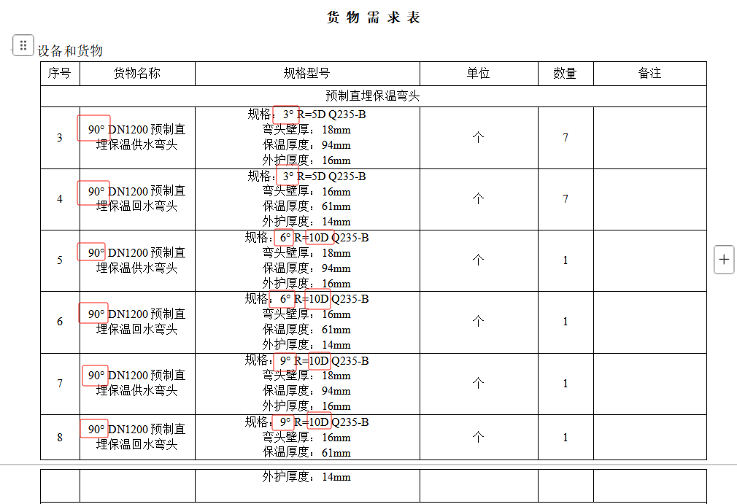
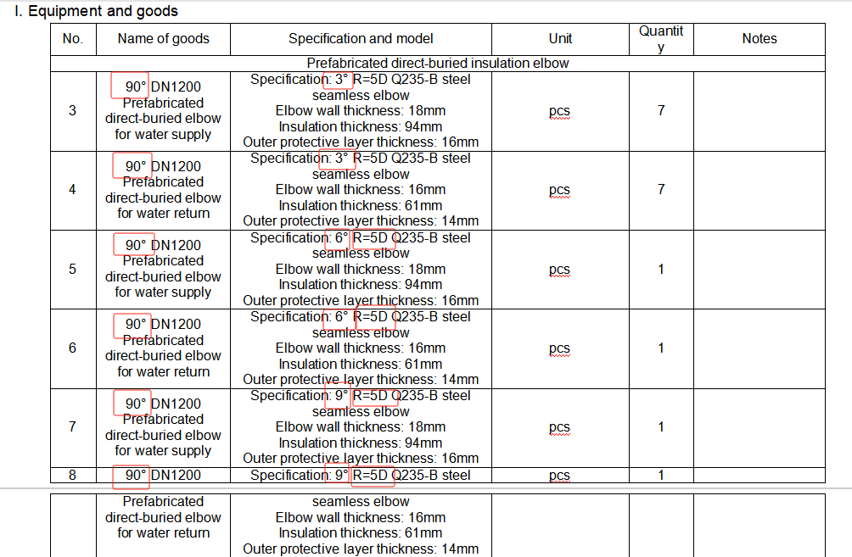

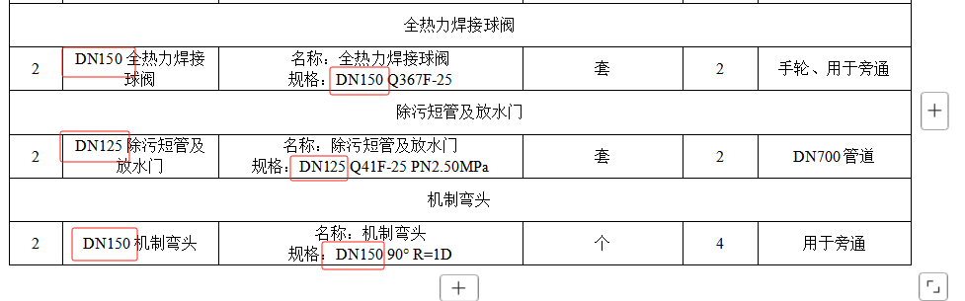
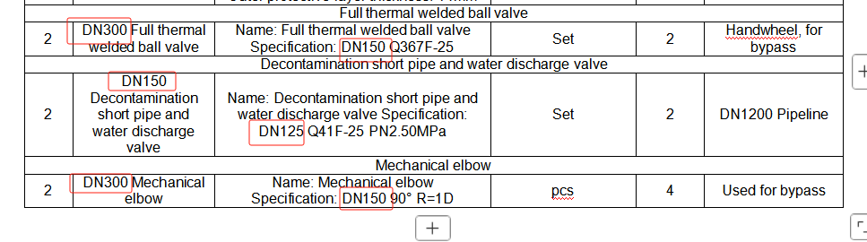
1. In the demand list above, the name, specification and model of goods, such as "prefabricated directly buried insulated elbow", "blow-down pipe and water release gate", "machined valve", and "Full thermal welded ball valve", are inconsistent. Which one shall prevail? Please clarify and harmonize.
问题1：以上货物需求表里预制直埋保温弯头、除污短管及防水门、机制弯头、全热力焊接球阀等材料部分的货物名称和规格型号前后不统一，以哪个为准，请招标人明确并统一。
回复：弯头以后面规格型号为准。 除污短管及防水门、机制弯头、全热力焊接球阀以中文版货物名称与规格型号为准。
Reply: The specifications and models of prefabricated directly buried insulated elbow shall prevail. The Chinese version of the name of goods，specification and model shall prevail for the blow-down pipe and water release gate, Mechanical elbow, and Full thermal welded ball valve.
2. The specifications and models for items 5, 6, 7, and 8 of the prefabricated directly buried insulated elbow in the above goods demand table are R=10D in Chinese and R=5D in English. Please clarify and unify which one shall prevail
问题2：以上货物需求表里预制直埋保温弯头第5、6、7、8项，其规格型号中文为R=10D，英文为R=5D，以哪个为准，请招标人明确并统一。
回复：以中文版R=10D为准。
Reply: The Chinese version with R=10D shall prevail.
三标段
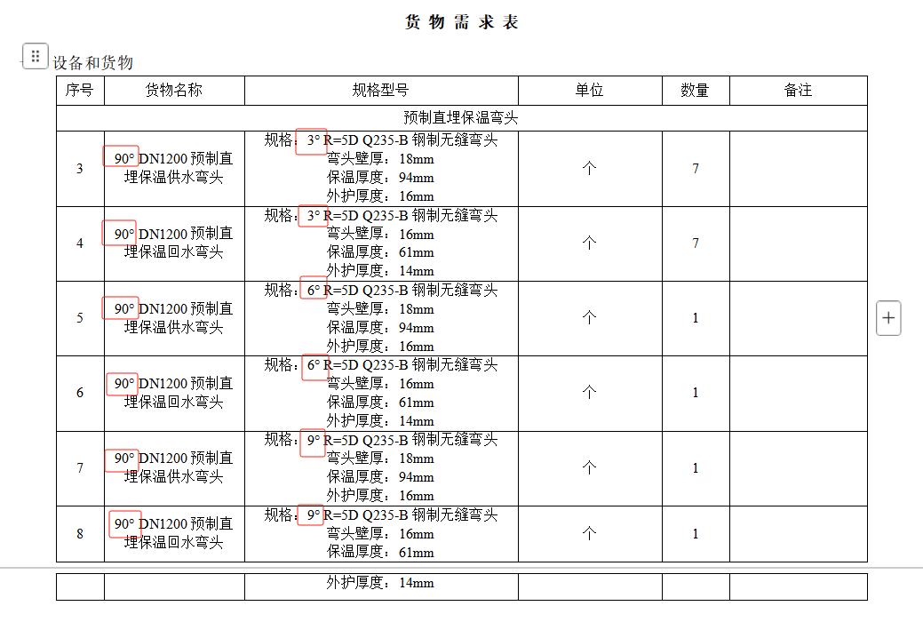
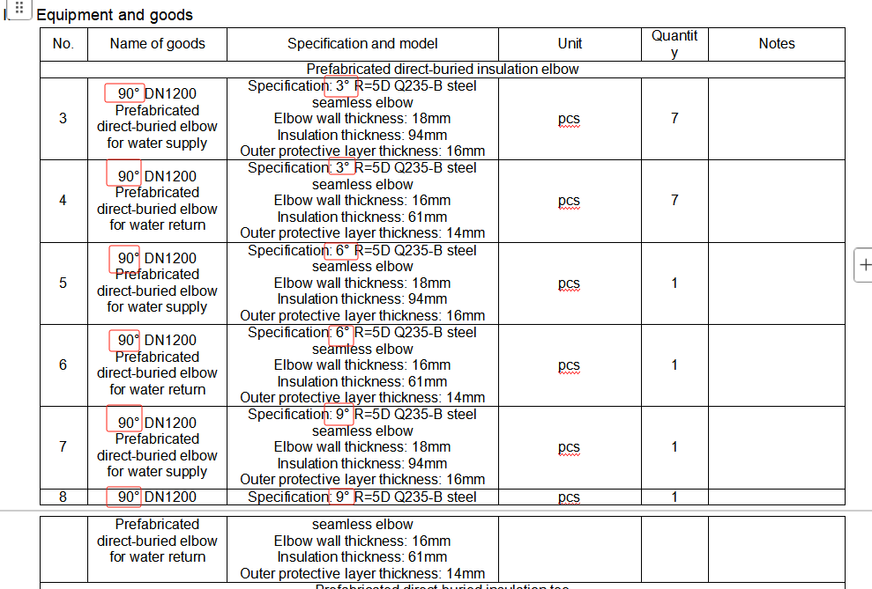

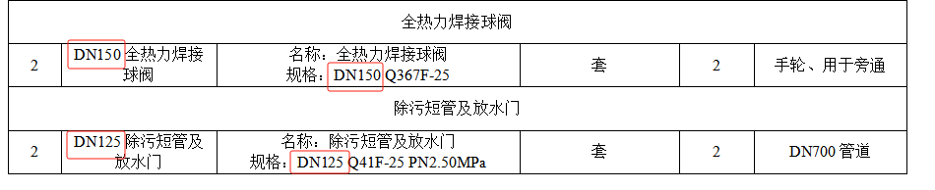
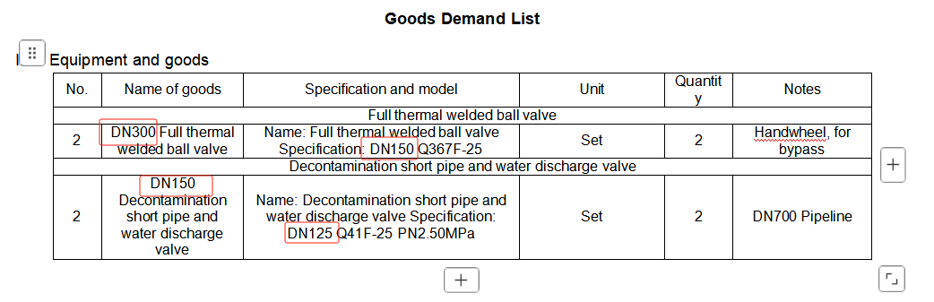
1. In the demand list above, the name, specification and model of goods, such as "prefabricated directly buried insulated elbow", "blow-down pipe and water release gate", and "Full thermal welded ball valve", are inconsistent. Which one shall prevail? Please clarify and harmonize.
问题1：以上货物需求表里预制直埋保温弯头、除污短管及防水门、全热力焊接球阀等材料部分的货物名称和规格型号前后不统一，以哪个为准，请招标人明确并统一。
回复：弯头以后面规格型号为准。 除污短管及防水门、机制弯头、全热力焊接球阀以中文版货物名称与规格型号为准。同时三标段6°及9°的弯头均调整为R=10D。
Reply: The specifications and models of prefabricated directly buried insulated elbow shall prevail. The Chinese version of the name of goods，specification and model shall prevail for the blow-down pipe and water release gate, Mechanical elbow, Full thermal welded ball valve. The 6 ° and 9 ° elbows of the Lot 3 are adjusted to R=10D.

其他内容保持不变。
Others Keep Unchanged.
中国远东国际招标有限公司
China Far East International Tendering Co., Ltd.
请贵公司确认收到澄清邮件后在第一页上书写“已收到澄清”并签字加盖公章，以确认收到本澄清。于2025年6月12日17：00前扫描后发邮件至我公司(邮箱：otnmxm@126.com)。

